Model coefficients for the best *N*-mixture model predicting abundance of Alder Flycatcher *Empidonax alnorum* from satellite-based data at the 50-m scale (AIC= 160.34) (A), 150-m scale (AIC= 162.19) (C), and 500-m scale (AIC= 165.38) (E), along with predicted abundances of this species in the Kirby grid from these respective models (B,D,F).

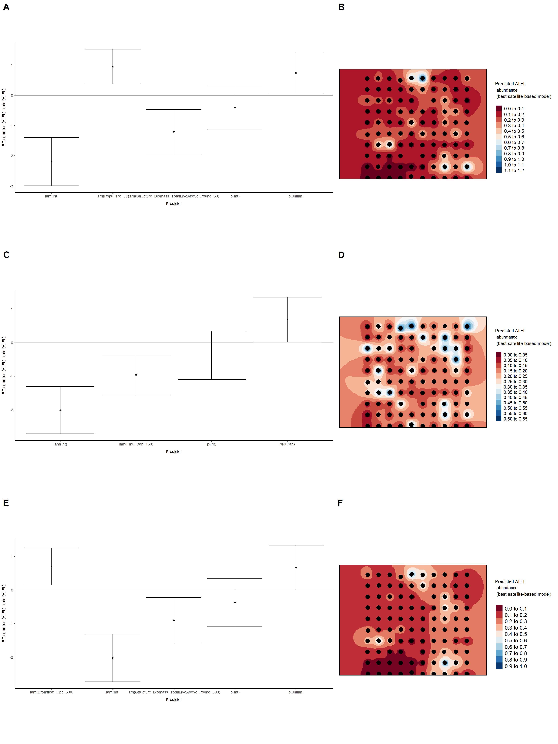

Model coefficients for the best *N*-mixture model predicting abundance of American Robin *Turdus migratorius* from satellite-based data at the 50-m scale (AIC= 291.12) (A), 150-m scale (AIC= 289.69) (C), and 500-m scale (AIC= 282.86) (E), along with predicted abundances of this species in the Kirby grid from these respective models (B,D,F).

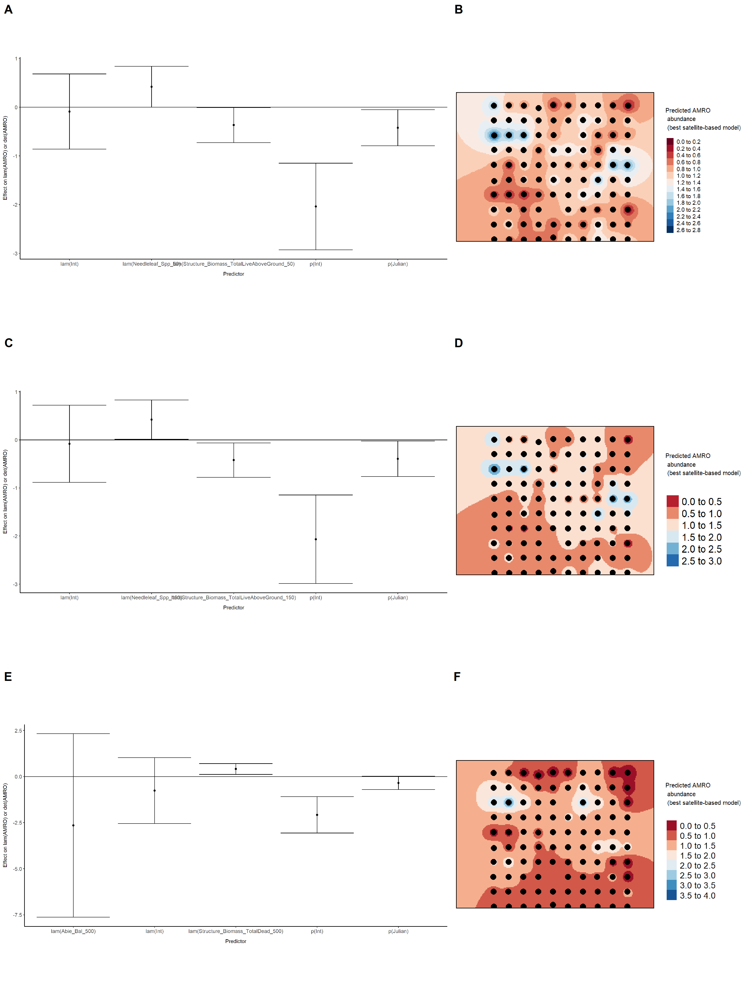

Model coefficients for the best *N*-mixture model predicting abundance of Boreal Chickadee *Poecile hudsonicus* from satellite-based data at the 50-m scale (AIC= 139.85) (A), 150-m scale (AIC= 141.04) (C), and 500-m scale (AIC= 135.83) (E), along with predicted abundances of this species in the Kirby grid from these respective models (B,D,F).

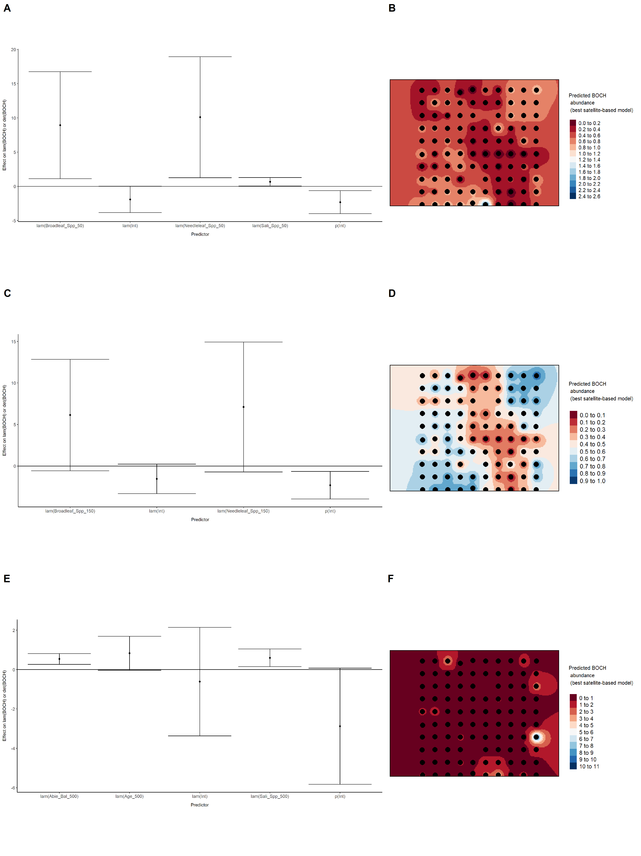

Model coefficients for the best *N*-mixture model predicting abundance of Cedar Waxwing *Bombycilla cedrorum* from satellite-based data at the 50-m scale (AIC= 126.43) (A), 150-m scale (AIC= 126.43) (C), and 500-m scale (AIC= 126.43) (E), along with predicted abundances of this species in the Kirby grid from these respective models (B,D,F).

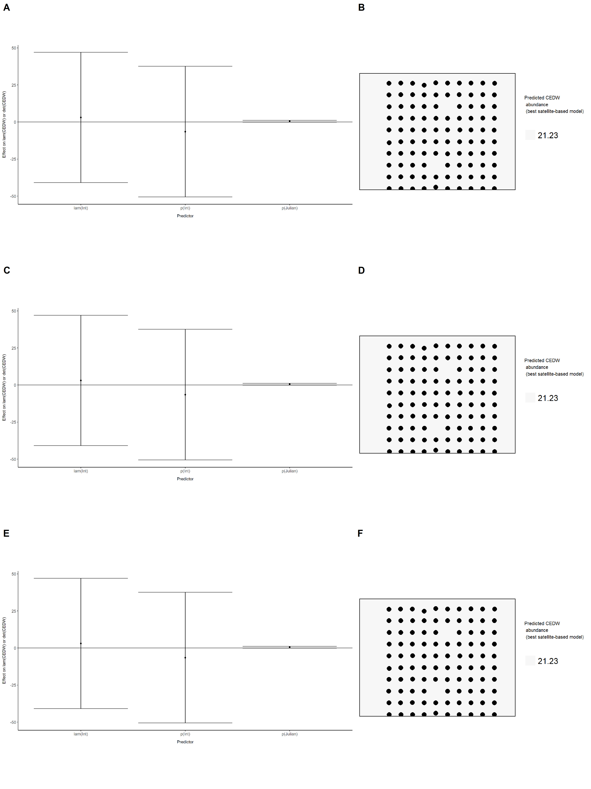

Model coefficients for the best *N*-mixture model predicting abundance of Chipping Sparrow *Spizella passerina* from satellite-based data at the 50-m scale (AIC= 578.98) (A), 150-m scale (AIC= 576.92) (C), and 500-m scale (AIC= 573) (E), along with predicted abundances of this species in the Kirby grid from these respective models (B,D,F).

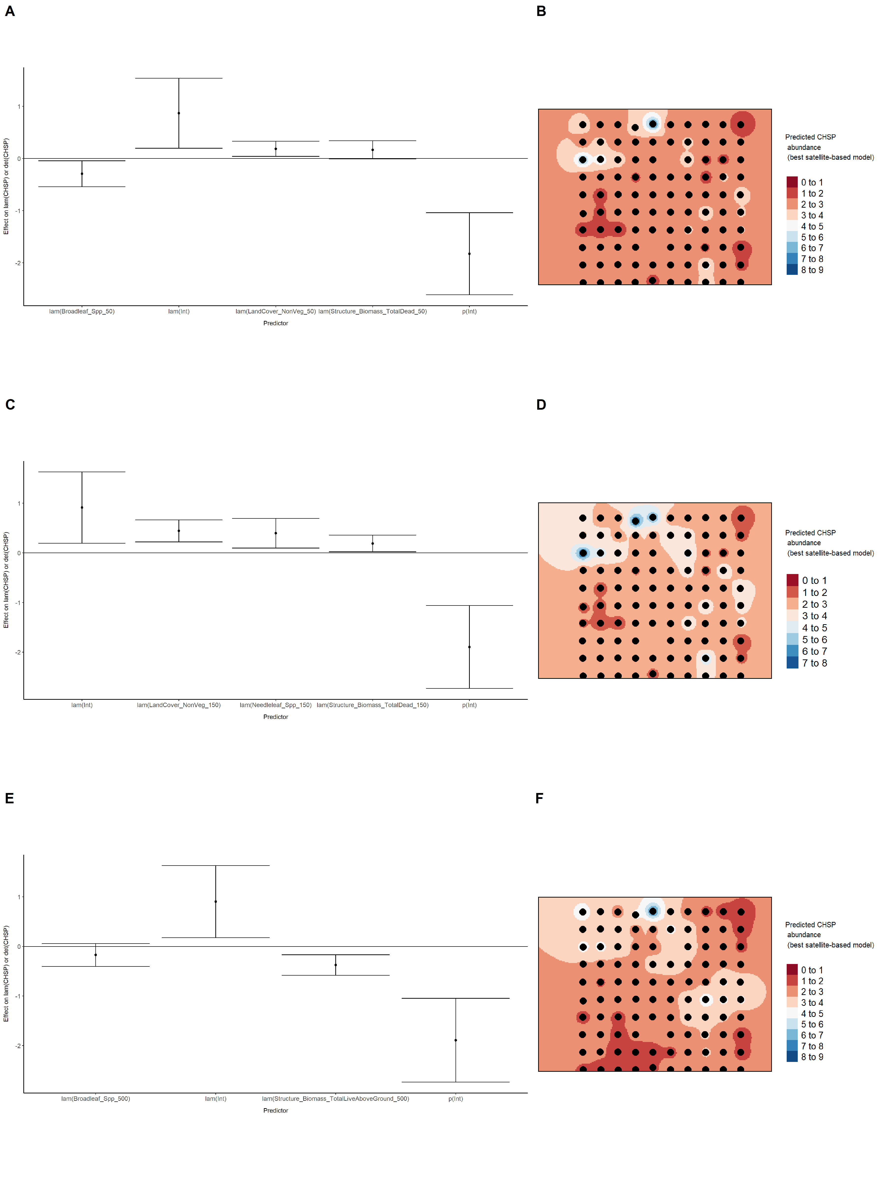

Model coefficients for the best *N*-mixture model predicting abundance of Common Yellowthroat *Geothlypis trichas* from satellite-based data at the 50-m scale (AIC= 124.84) (A), 150-m scale (AIC= 123.88) (C), and 500-m scale (AIC= 120) (E), along with predicted abundances of this species in the Kirby grid from these respective models (B,D,F).

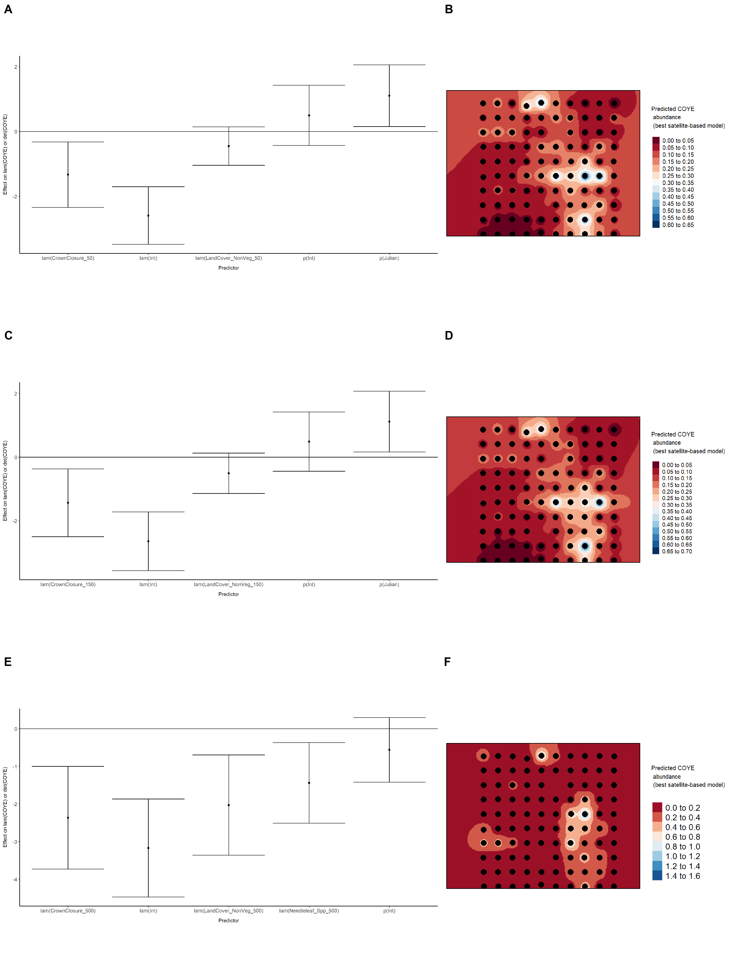

Model coefficients for the best *N*-mixture model predicting abundance of Dark-eyed Junco *Junco hyemalis* from satellite-based data at the 50-m scale (AIC= 436.37) (A), 150-m scale (AIC= 438.02) (C), and 500-m scale (AIC= 443) (E), along with predicted abundances of this species in the Kirby grid from these respective models (B,D,F).

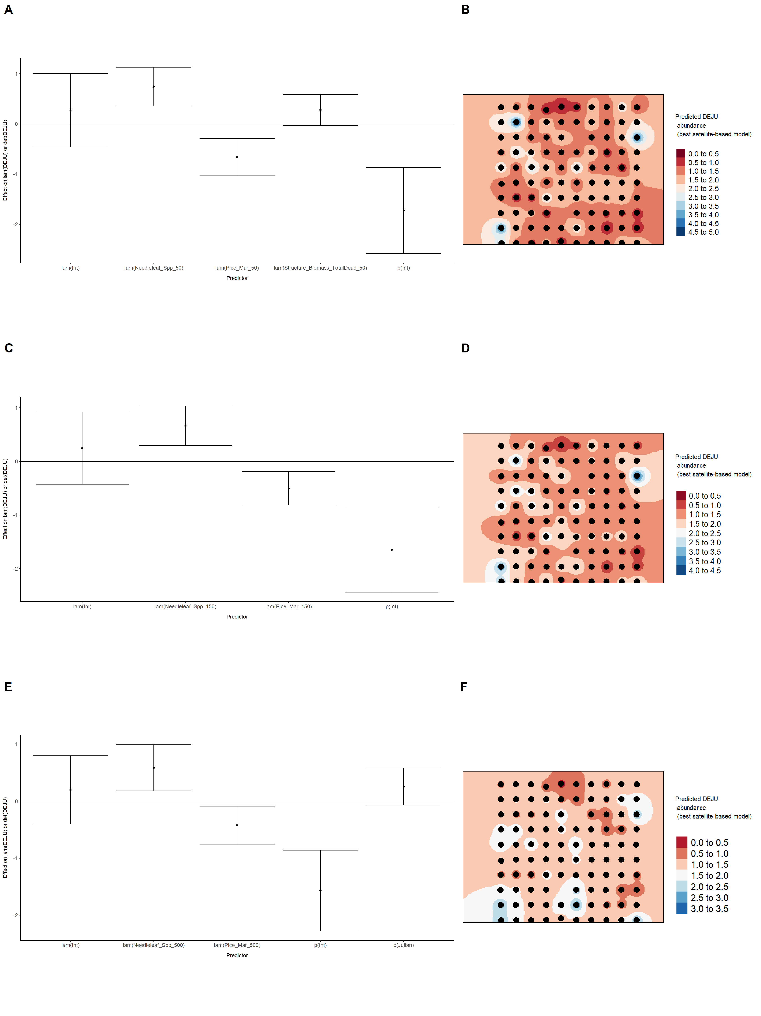

Model coefficients for the best *N*-mixture model predicting abundance of Gray Jay *Perisoreus canadensis* from satellite-based data at the 50-m scale (AIC= 460.21) (A), 150-m scale (AIC= 462.02) (C), and 500-m scale (AIC= 461.91) (E), along with predicted abundances of this species in the Kirby grid from these respective models (B,D,F).

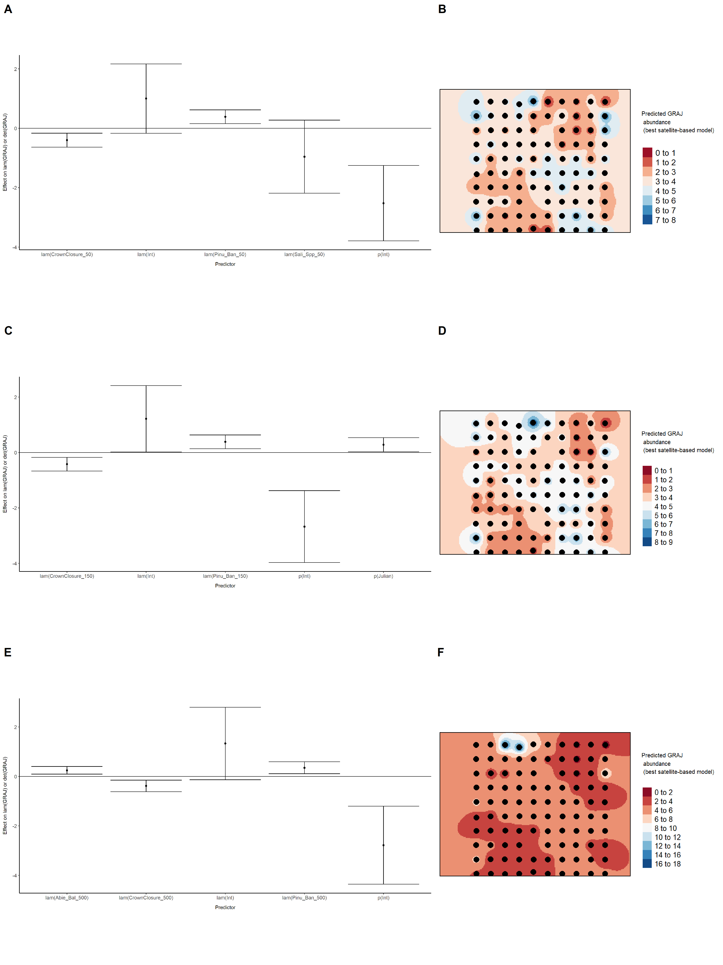

Model coefficients for the best *N*-mixture model predicting abundance of Hermit Thrush *Catharus guttatus* from satellite-based data at the 50-m scale (AIC= 694.13) (A), 150-m scale (AIC= 696.2) (C), and 500-m scale (AIC= 688.84) (E), along with predicted abundances of this species in the Kirby grid from these respective models (B,D,F).

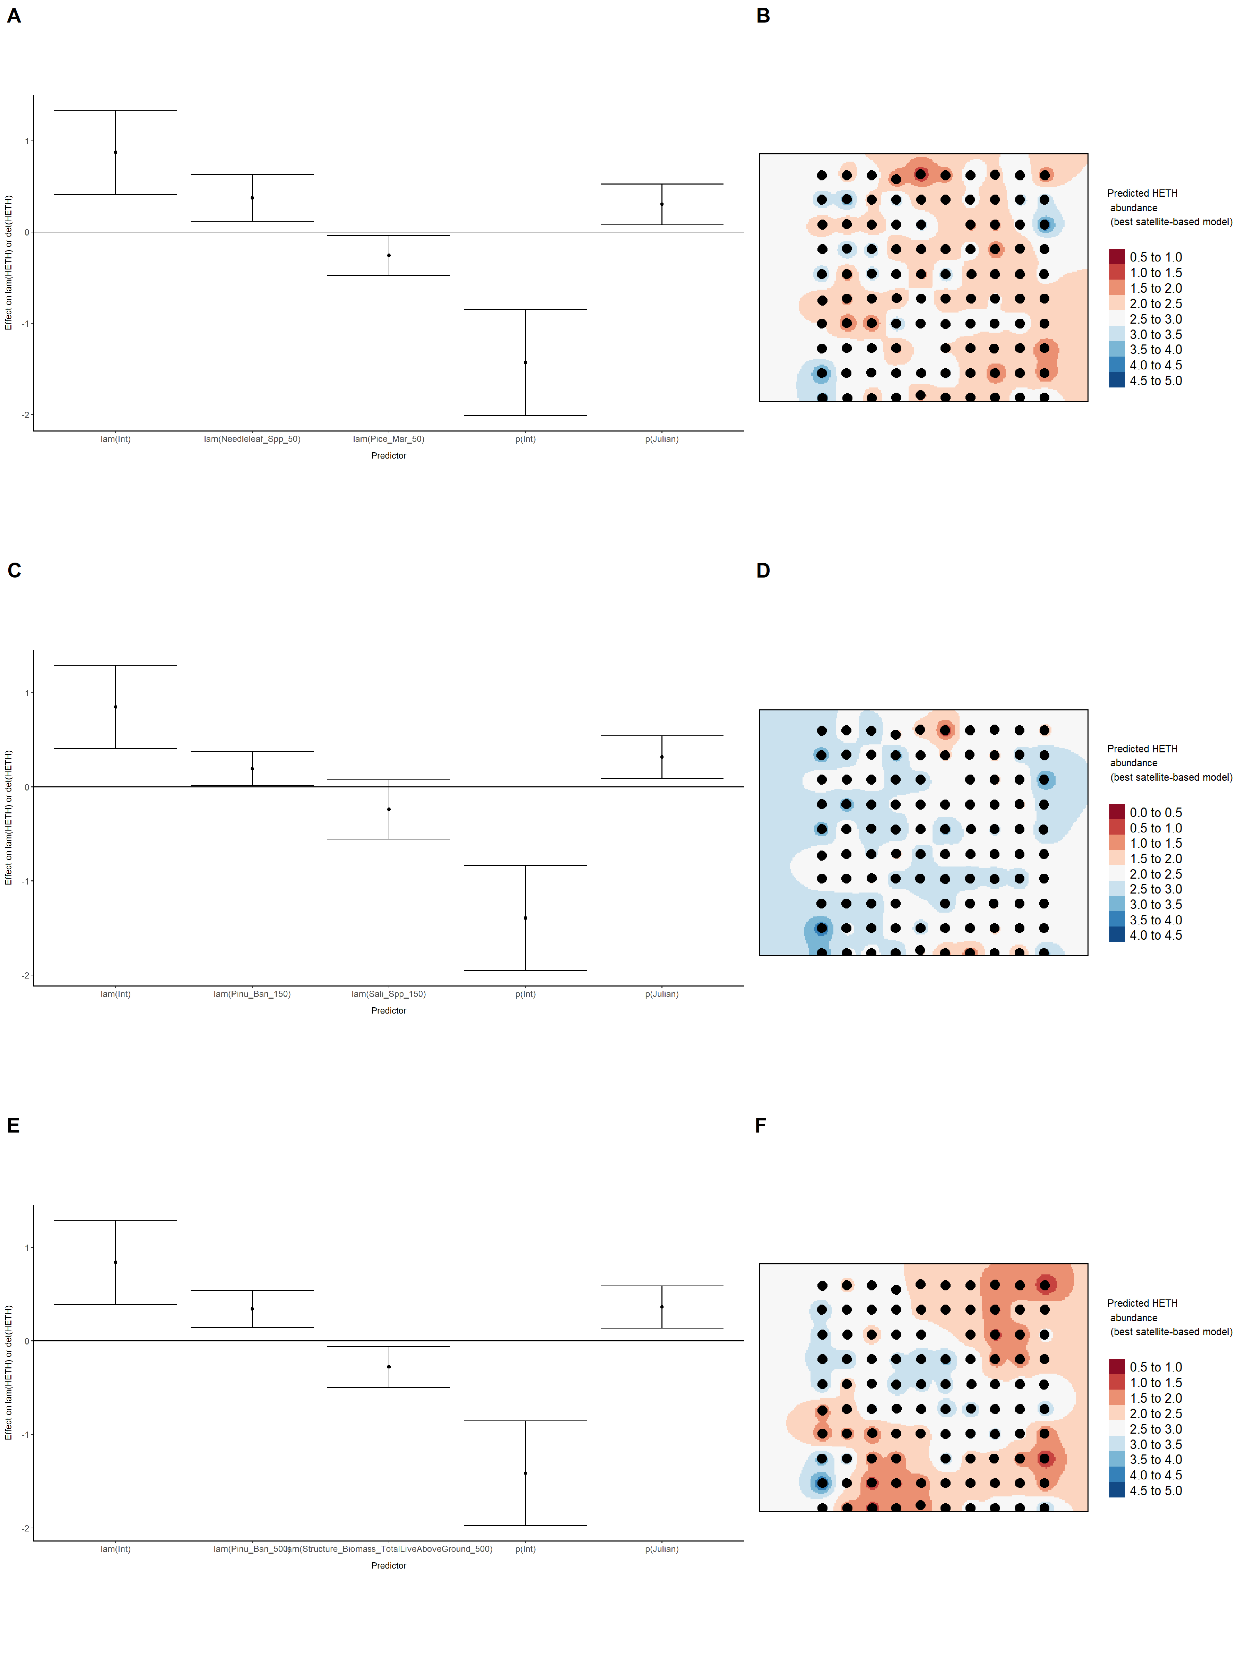

Model coefficients for the best *N*-mixture model predicting abundance of Le Conte’s Sparrow *Ammodramus lecontei* from satellite-based data at the 50-m scale (AIC= 238.75) (A), 150-m scale (AIC= 240.94) (C), and 500-m scale (AIC= 241.94) (E), along with predicted abundances of this species in the Kirby grid from these respective models (B,D,F).

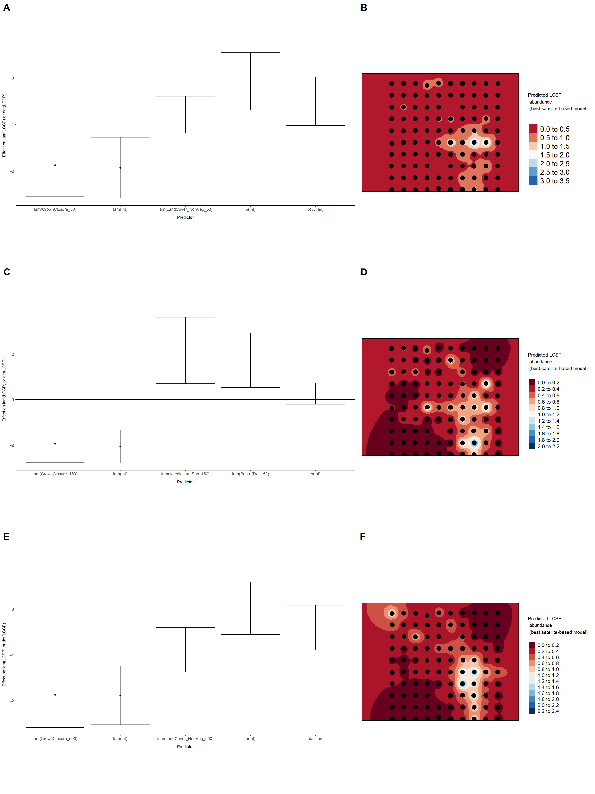

Model coefficients for the best *N*-mixture model predicting abundance of Lincoln’s Sparrow *Melospiza lincolnii* from satellite-based data at the 50-m scale (AIC= 469.21) (A), 150-m scale (AIC= 465.2) (C), and 500-m scale (AIC= 465.87) (E), along with predicted abundances of this species in the Kirby grid from these respective models (B,D,F).

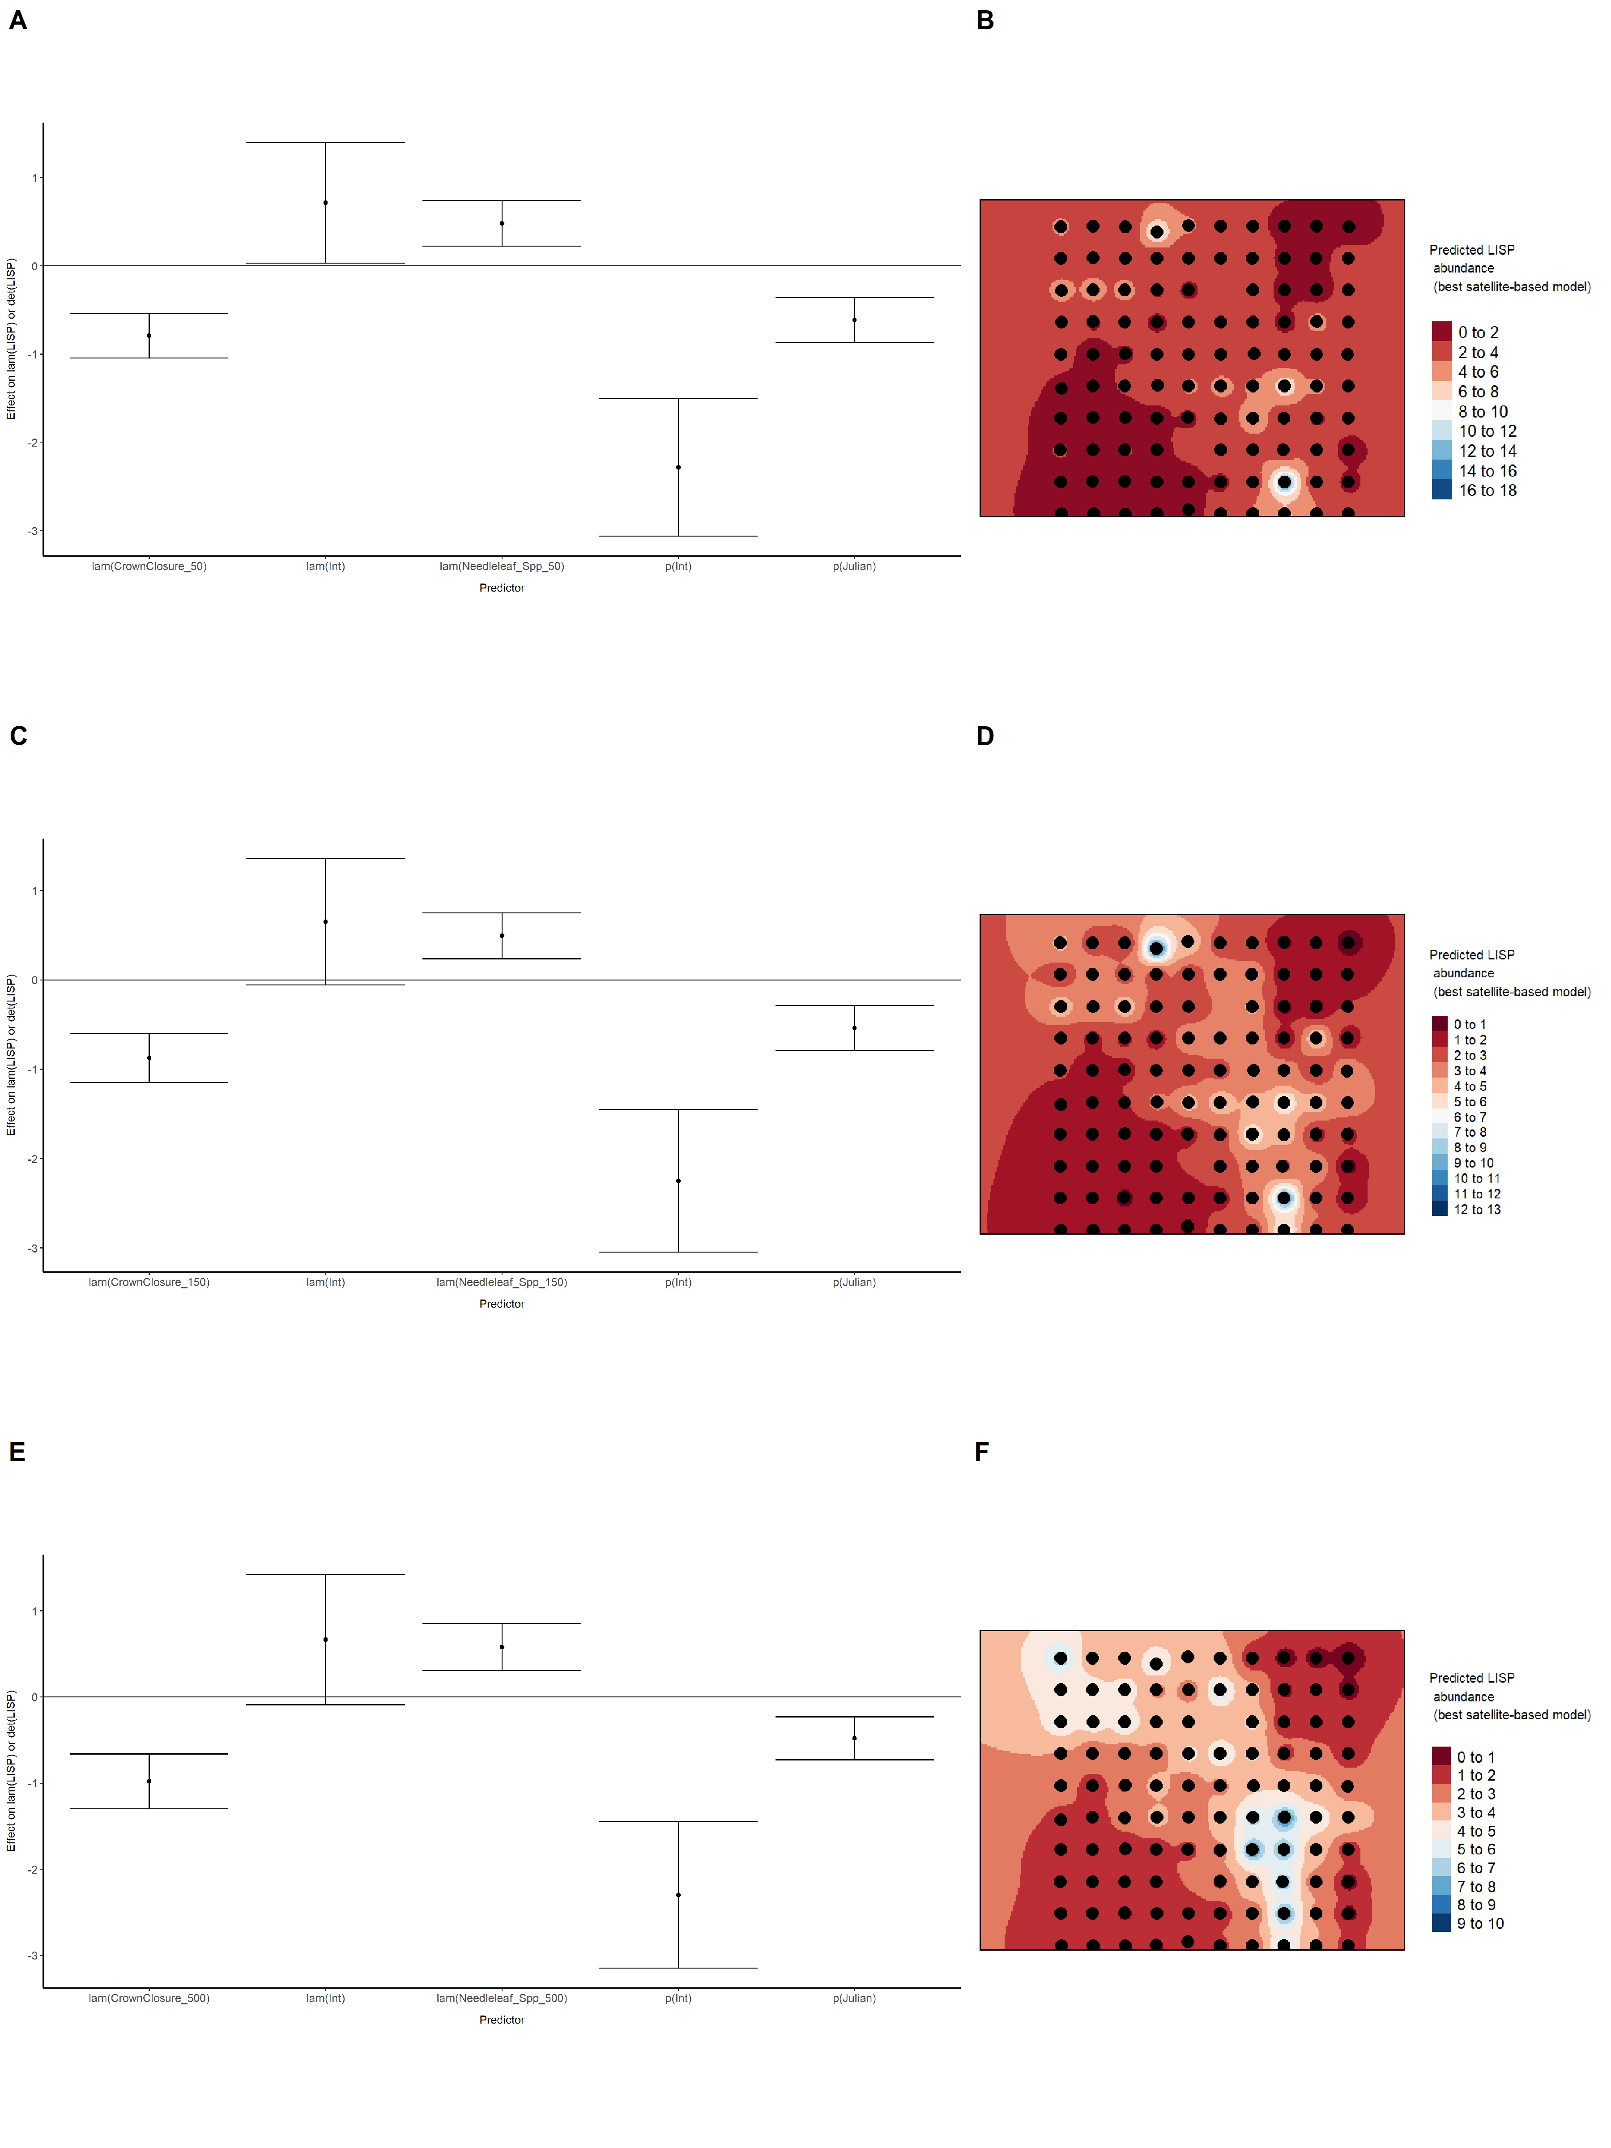

Model coefficients for the best *N*-mixture model predicting abundance of Olive-sided Flycatcher *Contopus cooperi* from satellite-based data at the 50-m scale (AIC= 153.33) (A), 150-m scale (AIC= 148.27) (C), and 500-m scale (AIC= 130.55) (E), along with predicted abundances of this species in the Kirby grid from these respective models (B,D,F).

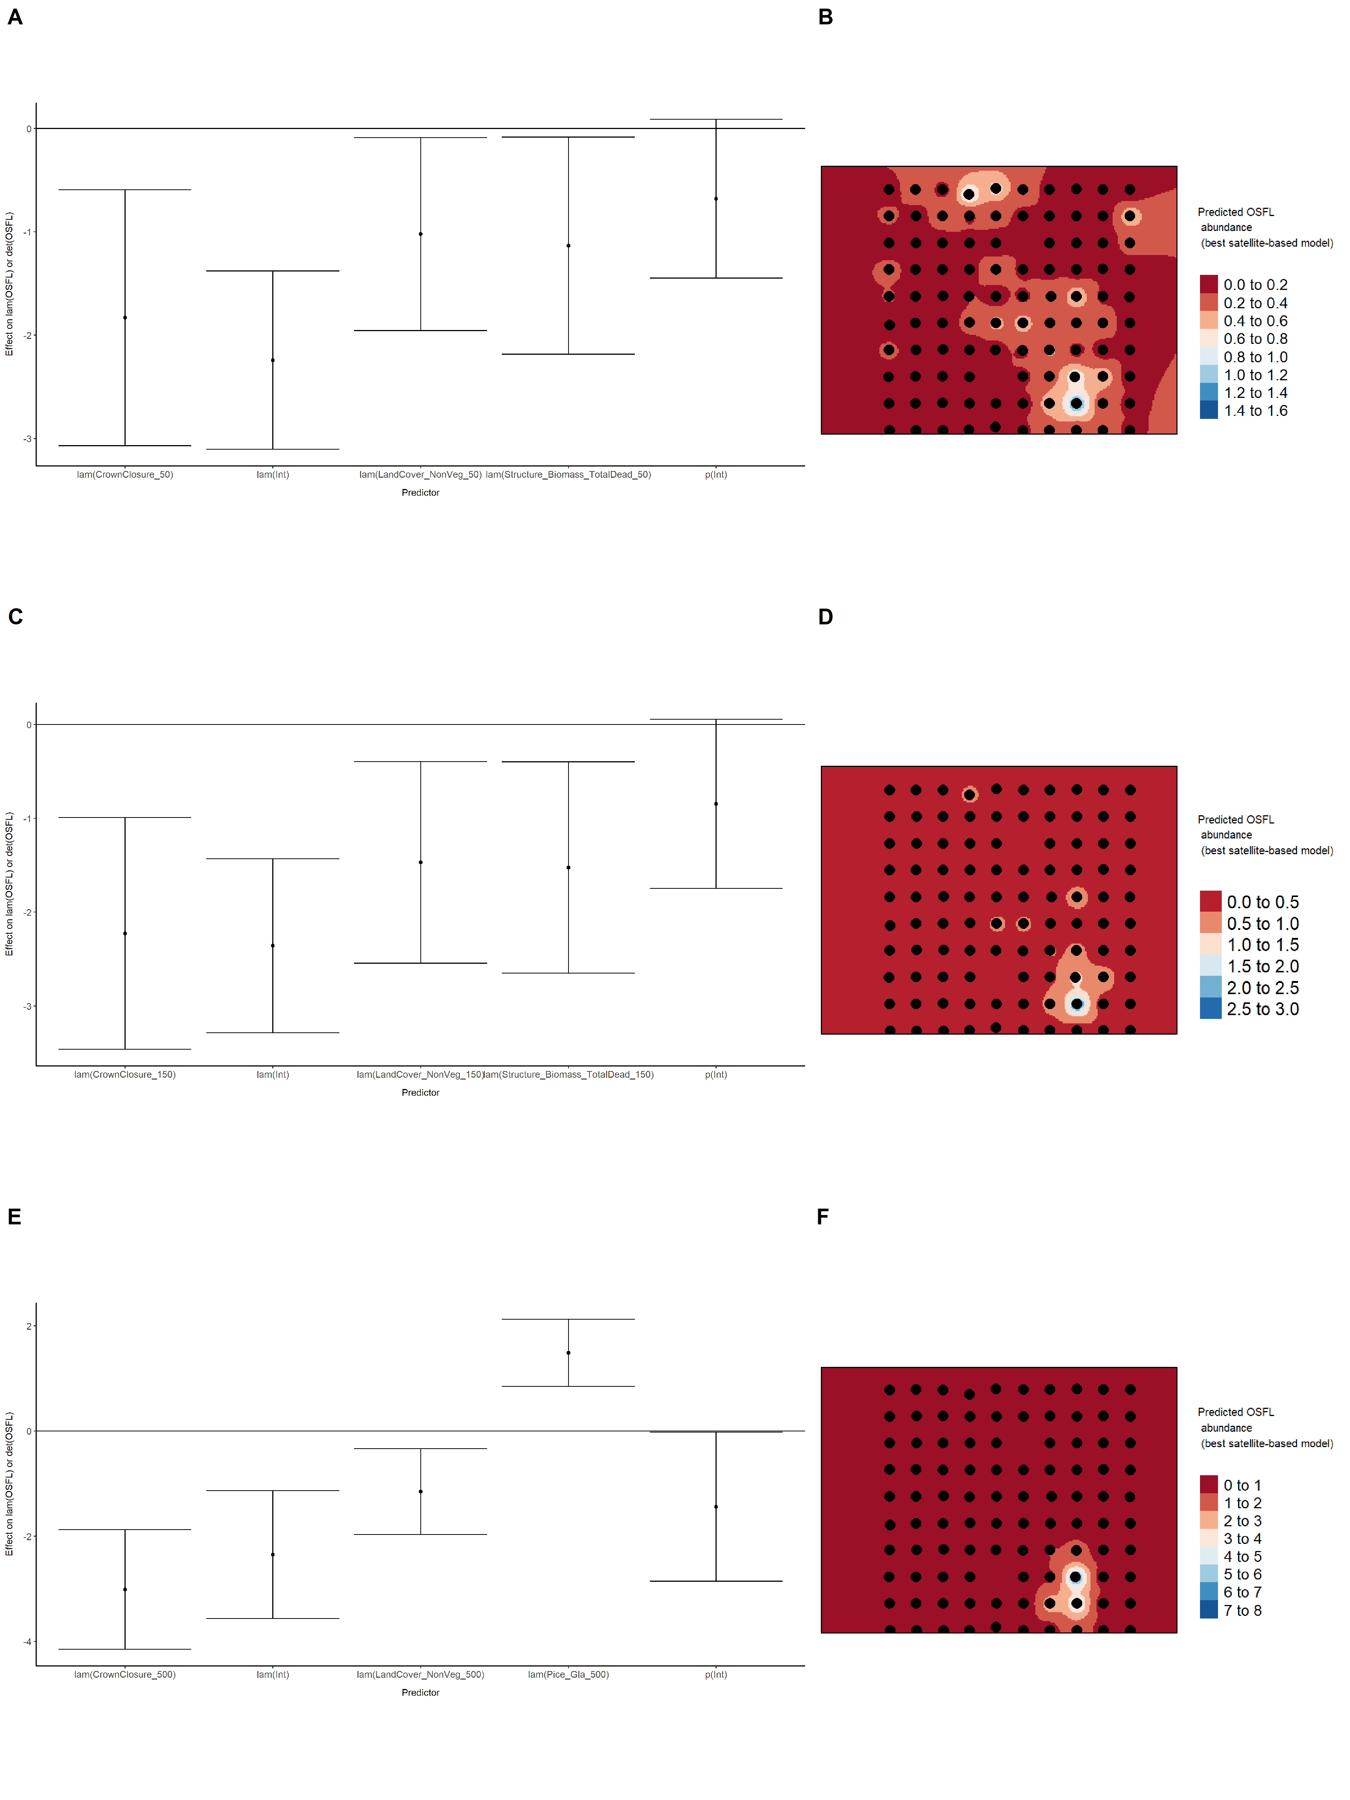

Model coefficients for the best *N*-mixture model predicting abundance of Ovenbird *Seiurus aurocapillus* from satellite-based data at the 50-m scale (AIC= 337.23) (A), 150-m scale (AIC= 338.74) (C), and 500-m scale (AIC= 334.09) (E), along with predicted abundances of this species in the Kirby grid from these respective models (B,D,F).

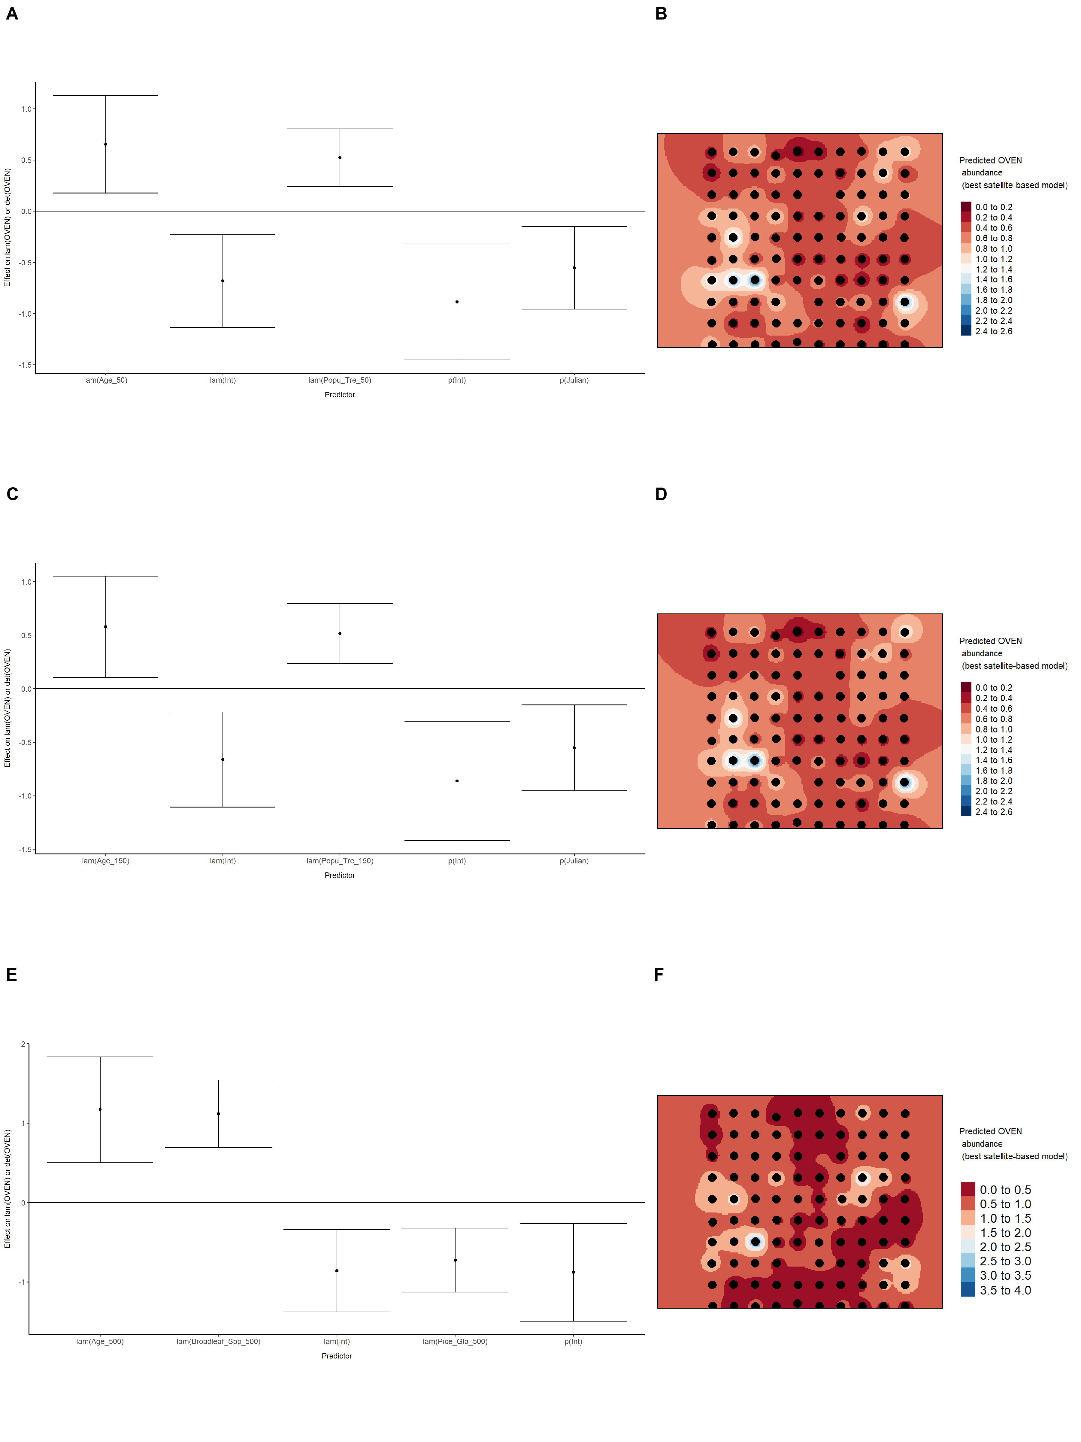

Model coefficients for the best *N*-mixture model predicting abundance of Palm Warbler *Setophaga palmarum* from satellite-based data at the 50-m scale (AIC= 166.13) (A), 150-m scale (AIC= 165.04) (C), and 500-m scale (AIC= 164.33) (E), along with predicted abundances of this species in the Kirby grid from these respective models (B,D,F).

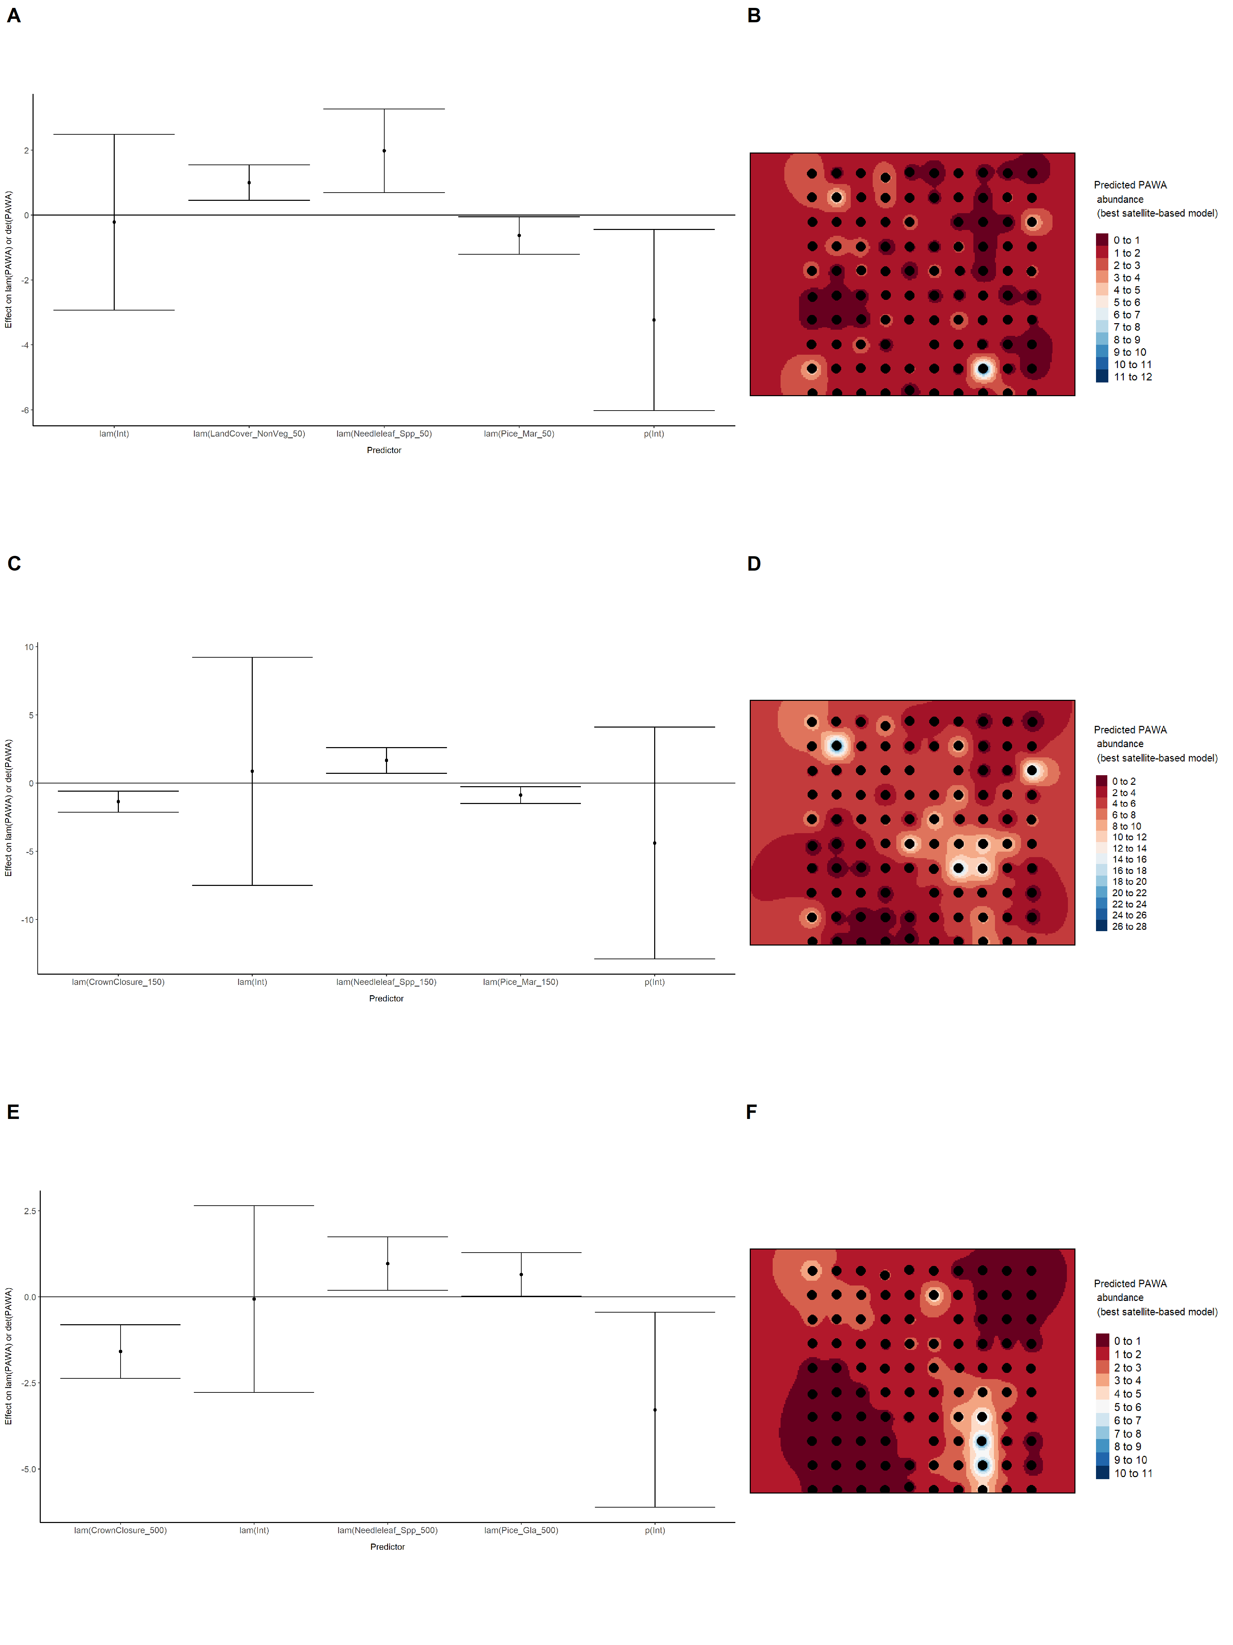

Model coefficients for the best *N*-mixture model predicting abundance of Red-eyed Vireo *Vireo olivaceus* from satellite-based data at the 50-m scale (AIC= 286.47) (A), 150-m scale (AIC= 286.96) (C), and 500-m scale (AIC= 280.83) (E), along with predicted abundances of this species in the Kirby grid from these respective models (B,D,F).

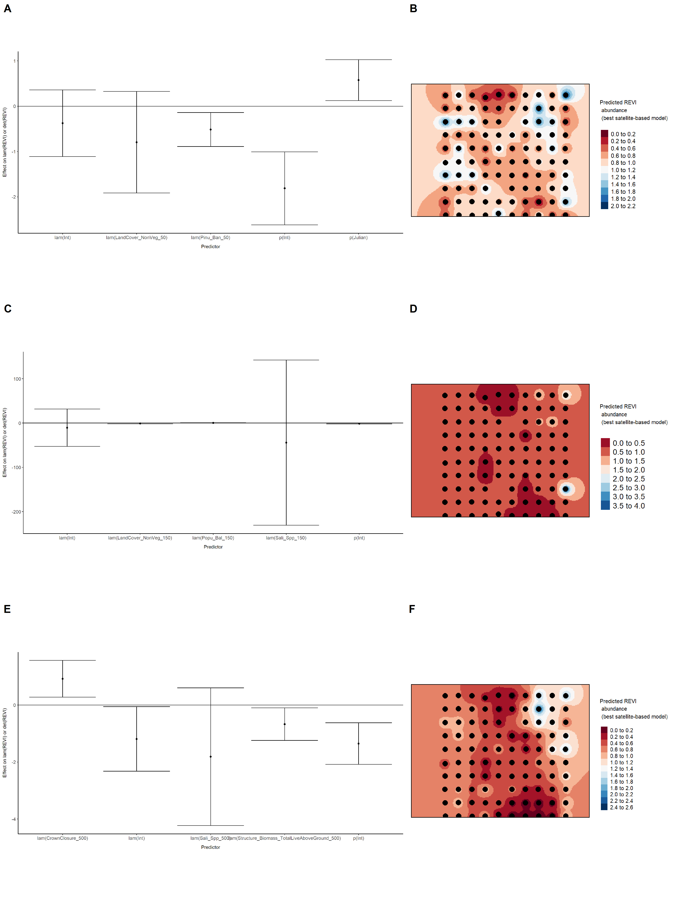

Model coefficients for the best *N*-mixture model predicting abundance of Ruby-crowned Kinglet *Regulus calendula* from satellite-based data at the 50-m scale (AIC= 362.17) (A), 150-m scale (AIC= 362.83) (C), and 500-m scale (AIC= 357.62) (E), along with predicted abundances of this species in the Kirby grid from these respective models (B,D,F).

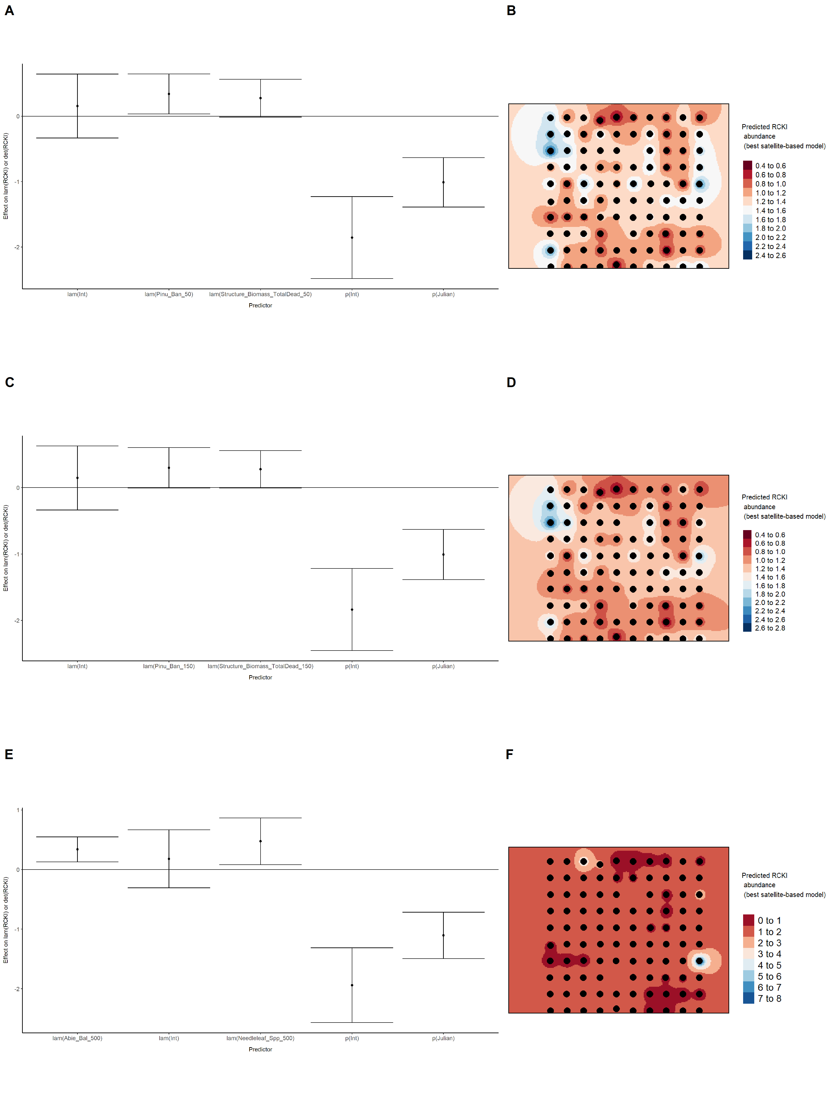

Model coefficients for the best *N*-mixture model predicting abundance of Swainson’s Thrush *Catharus ustulatus* from satellite-based data at the 50-m scale (AIC= 656.31) (A), 150-m scale (AIC= 654.1) (C), and 500-m scale (AIC= 657.54) (E), along with predicted abundances of this species in the Kirby grid from these respective models (B,D,F).

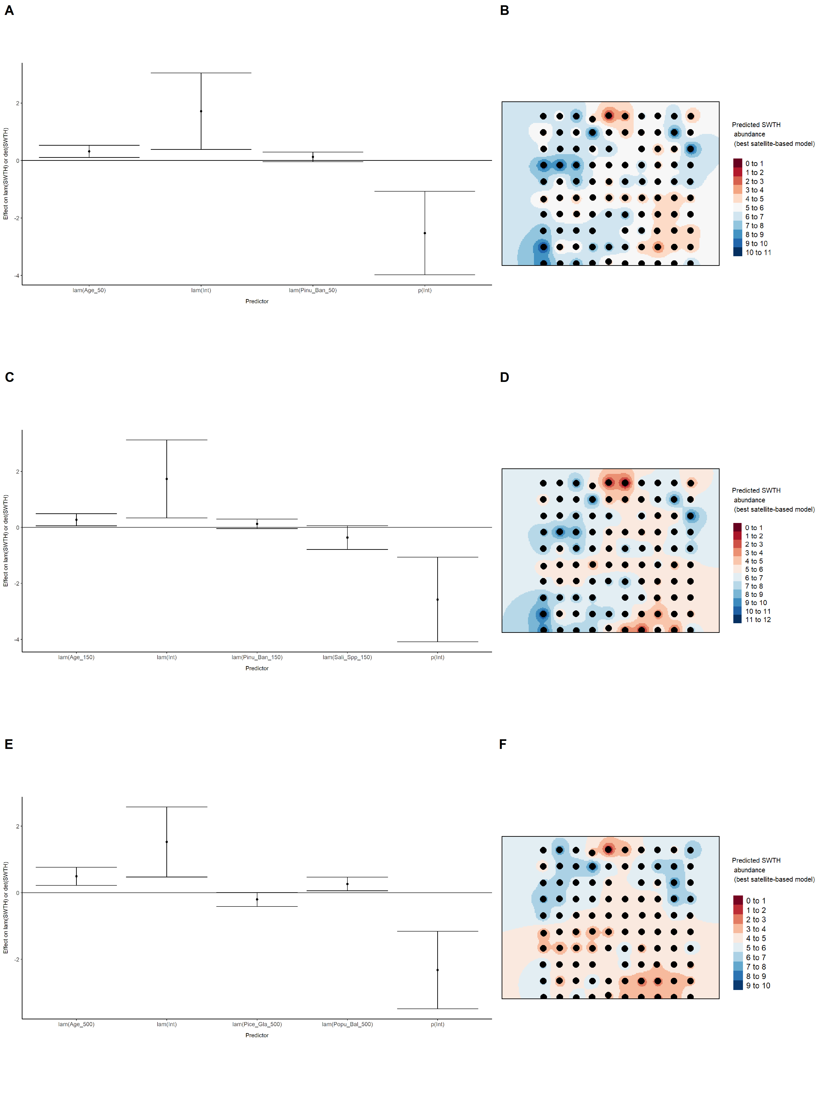

Model coefficients for the best *N*-mixture model predicting abundance of Swamp Sparrow *Melospiza georgiana* from satellite-based data at the 50-m scale (AIC= 143.31) (A), 150-m scale (AIC= 139.33) (C), and 500-m scale (AIC= 139.77) (E), along with predicted abundances of this species in the Kirby grid from these respective models (B,D,F).

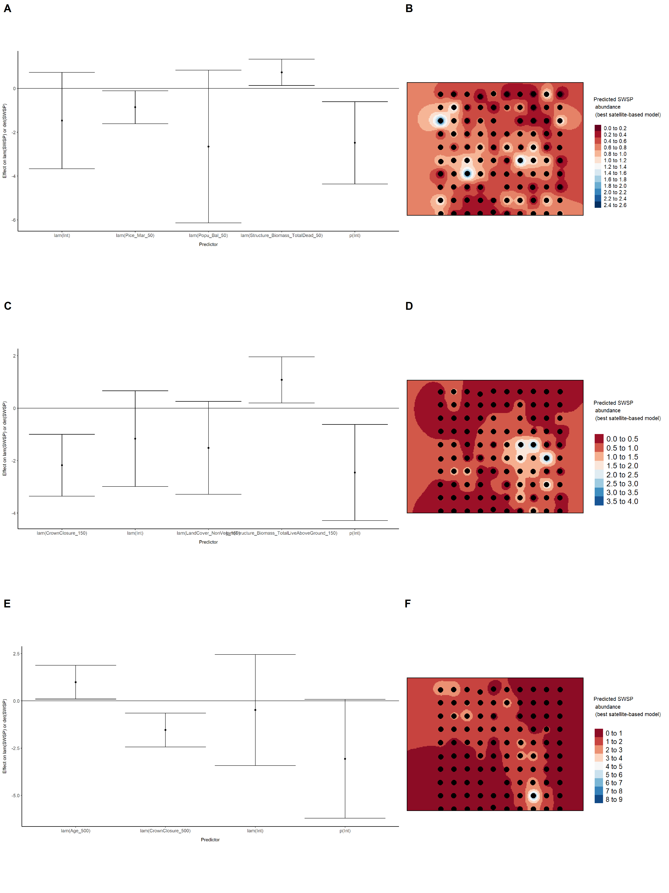

Model coefficients for the best *N*-mixture model predicting abundance of Tennessee Warbler *Leiothlypis peregrina* from satellite-based data at the 50-m scale (AIC= 327.76) (A), 150-m scale (AIC= 326.37) (C), and 500-m scale (AIC= 322.11) (E), along with predicted abundances of this species in the Kirby grid from these respective models (B,D,F).

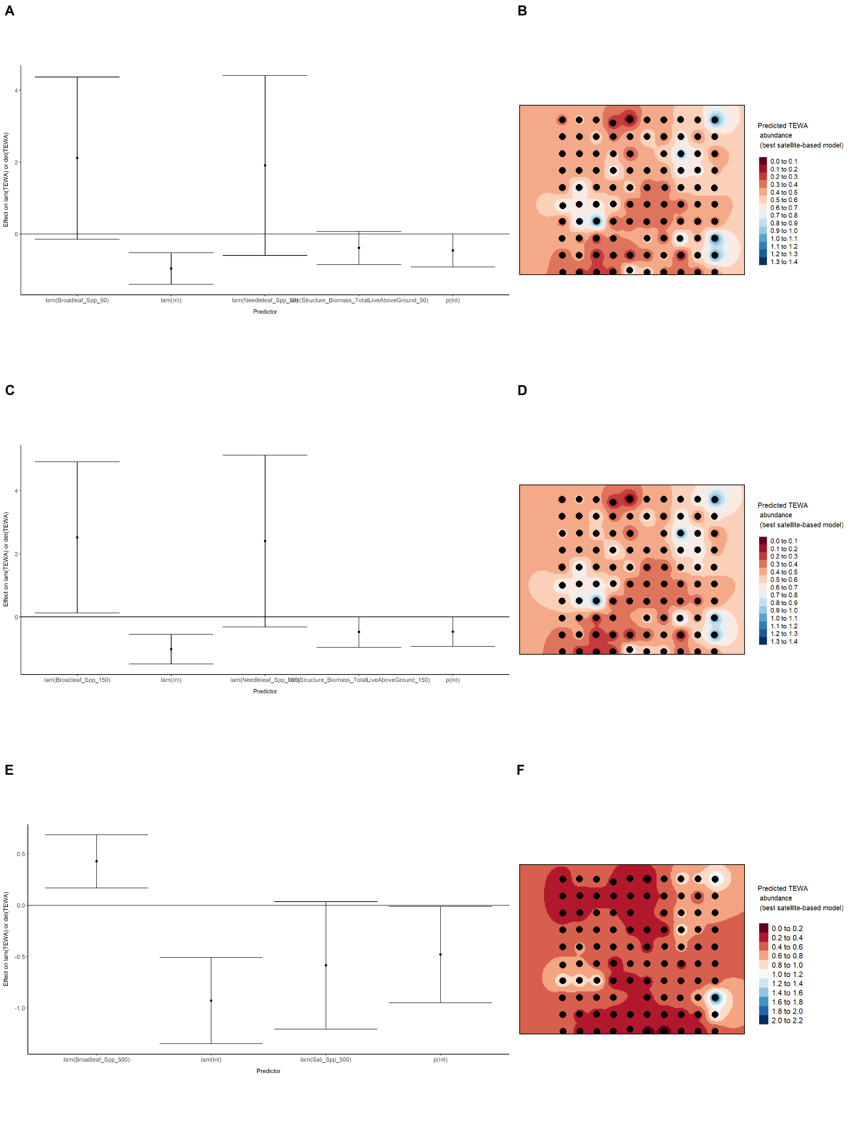

Model coefficients for the best *N*-mixture model predicting abundance of Winter Wren *Troglodytes hiemalis* from satellite-based data at the 50-m scale (AIC= 273.12) (A), 150-m scale (AIC= 272.44) (C), and 500-m scale (AIC= 269.42) (E), along with predicted abundances of this species in the Kirby grid from these respective models (B,D,F).

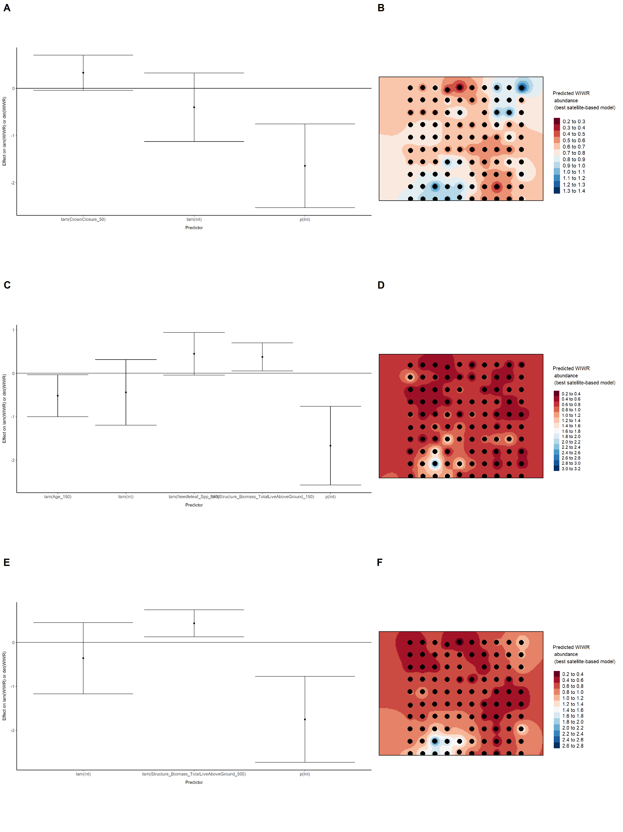

Model coefficients for the best *N*-mixture model predicting abundance of White-throated Sparrow *Zonotrichia albicollis* from satellite-based data at the 50-m scale (AIC= 327.4) (A), 150-m scale (AIC= 326.85) (C), and 500-m scale (AIC= 312.28) (E), along with predicted abundances of this species in the Kirby grid from these respective models (B,D,F).

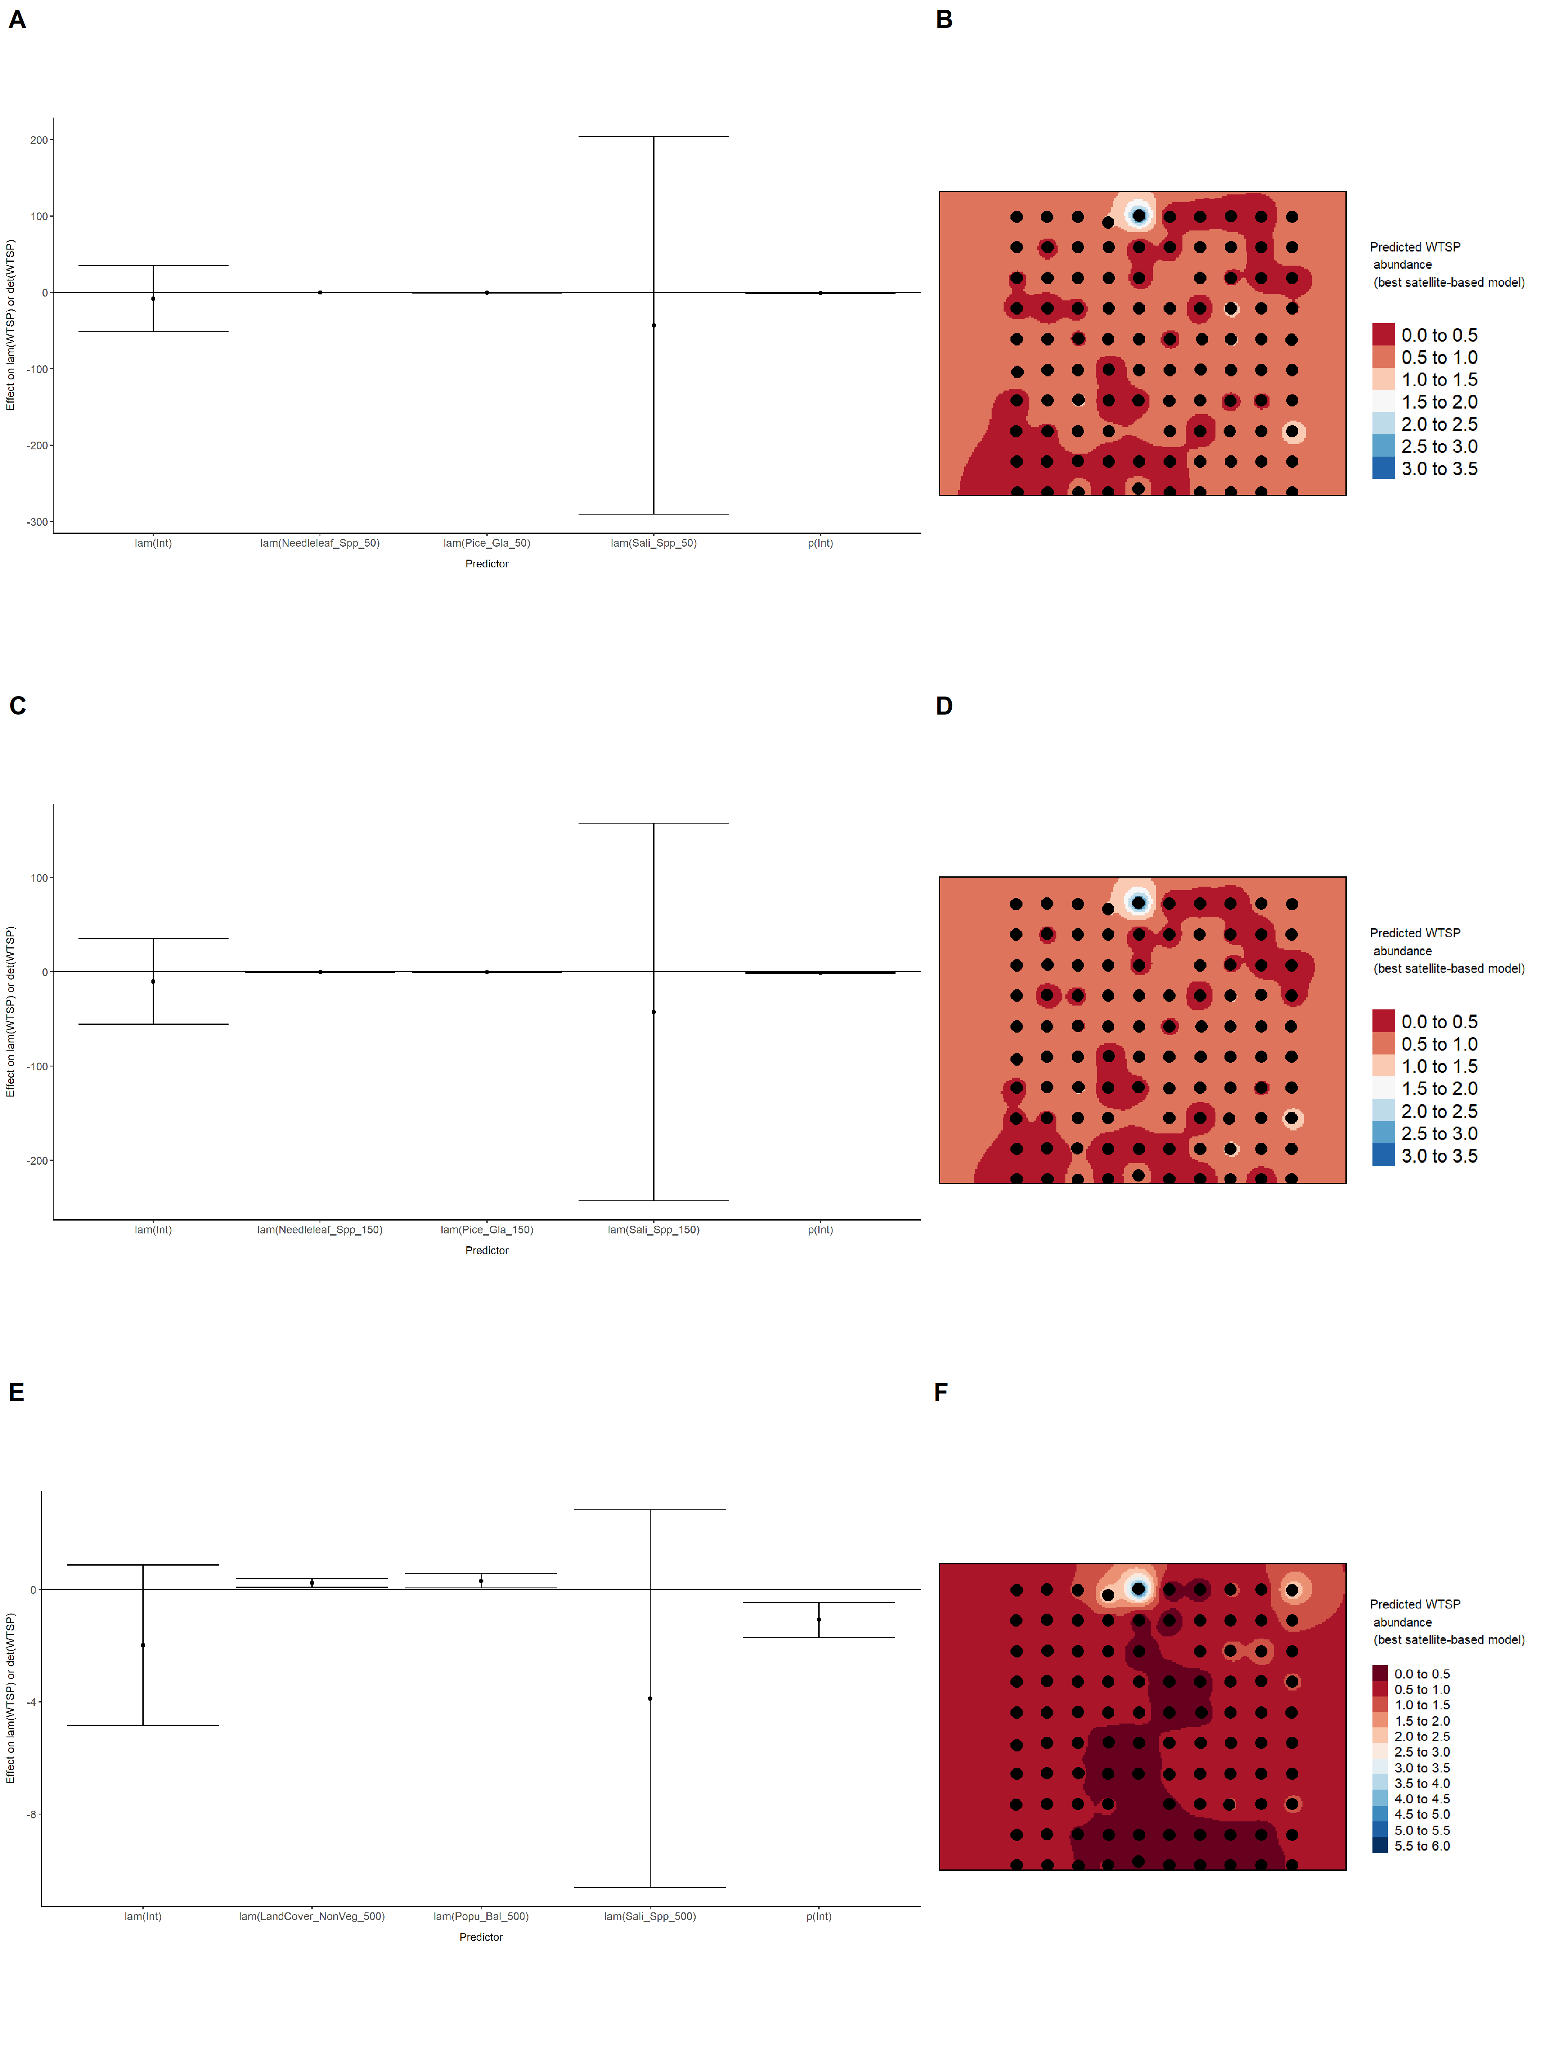

Model coefficients for the best *N*-mixture model predicting abundance of Yellow-rumped Warbler *Setophaga coronata* from satellite-based data at the 50-m scale (AIC= 679.02) (A), 150-m scale (AIC= 680.76) (C), and 500-m scale (AIC= 683.36) (E), along with predicted abundances of this species in the Kirby grid from these respective models (B,D,F).

